**Experimantal Environment**

OS – Windows 8.1, Ubuntu

Softwares used – 1. Jflap : for verifcation of reglar language

2.Jupyter notebook : for python scripting

3. Sciitkit Learn : Machine Learning Classifiers library

4. Eclipse IDE : for writing parser in JAVA

**Testing data pie chart**

* You did this.

**Classifier accuracy plot**

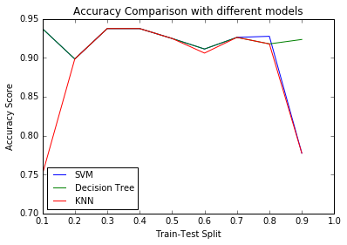

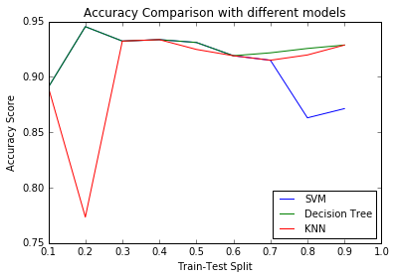

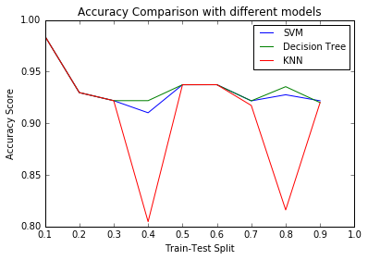

**Why FSM**

1.As we have seen above the accuracy score of different ML models vary depending upon the splitting of available data.

Also for different data size the same splitting will result in different accuracy scores.

By using FSM for constructing the model we will eliminate this shortcoming.

2. Also it is not possible to train models with different number of features(which highly observe in tweets, i.e. tweets of different lengths)

Hence the bag of word will differ for insance to instance. To overcome this situation we have to extract fixed number of features and have to neglect the other ones.

3. By using FSM, we will be able to retain the dependency between different features but that is not possible in ML training models.

Like coming of “U_NAME after @ “ and “TREND after #” can not be checked in ML training models.

And this shortcomings highly suggest to use FSM instead of ML training.

**5 TP, TN, FP, FN**

**TP:**

* .@apple you got me. I'm now invested. MacBook Pro next year. Time to get on selling more of my #android gear
* @iancollinsuk @apple I like what you did there...!
* I just sent my grandma a post card using my #CardsApp thanks @Apple
* Sorry @BlackBerry, I'm moving to @Apple.
* RT @igorlilmonster: My #twitter age is 2 years 153 days 5 hours 6 minutes 25 seconds. Find out yours at http://t.co/NjTHu7tM #twittertime

**FP:**

* One of the leading complaints about [#VPN](https://www.facebook.com/hashtag/vpn?source=feed_text&story_id=1473379059347216) services is that they slow your browsing experience to a crawl
* German Academic Exchange Service (DAAD​) WISE (Working Internships in Science and Engineering): <https://goo.gl/RlKYhz> (Deadline: November 1, 2016)
* Net and Autocad trainer for my training Institute.If anybody Interested.Ping me @ 959 949 3069
* How to Run MySQL/MariaDB Queries Directly from the [#Linux](https://www.facebook.com/hashtag/linux?source=feed_text&story_id=1471497999535322)Command Line
* This Friday @LA 214!!! Come and join us.

**TN:**

* woke up dis morning so i'm stil alive
* My phone would stay charged if I didnt have
* you got 18 mentions go click on them , run , run , run :::::::: only 1 new ::::: ha ha ha ha
* Damn tired! .. Need some rest! Night
* The more i use Office 2010 the more i fall in love it with.

**FN:**

* A 31-year-old man from India arrested in Mexico's Guadalajara city for allegedly shooting an American diplomat (PTI)
* Concerns of Indian women marrying into NRI families can be most effectively addressed by local community organisations abroad: President
* Prez Pranab Mukherjee expresses concern over plight of temporary migrants in Gulf region, south east Asia; pitches for their skill upgrade
* 9 policemen killed, 14 injured as ISIS-linked suicide bombers ram truck laden with explosives into security checkpoint in Egypt (PTI)
* 9 policemen killed, 14 injured as ISIS-linked suicide bombers ram truck laden with explosives into security checkpoint in Egypt

**TN:**

**RE for final DFA**

Qs=lambda

Q0=Eng

Q1=RT+Q0.RT+Qf.RT

=RT+Eng.RT+Qf.RT

Q2= @+Eng.@+Q1.@+Qf.@

=@ + Eng.@ +RT.@+ENG.RT.@ +Qf.(@+RT.@)

Q3= # +Eng.#+Qf.#

Qf= URL +Eng.URL+Q3.TREND + Qf.(Eng+URL)+Q2.U_NAME

To find the RE for state Q4 which is a final state we expressed every other term in terms of Q4, so that we can use Arden’s theorem

Qf=URL +Eng.URL+#.TREND +Eng.#.TREND+

(@+Eng.@+RT.@+Eng.RT.@).U_NAME+

Qf.(Eng +URL+#.TREND+@.U_NAME+RT.@.U_NAME)

Now using Arden’s theorem, we get RE for Q4 and hence for the FSM as follows

Qf= [ URL +Eng.URL+#.TREND +Eng.#.TREND+

(@+Eng.@+RT.@+Eng.RT.@).U_NAME].

[Eng +URL+#.TREND+@.U_NAME+RT.@.U_NAME]*